An Introduction to Oral History Methodology
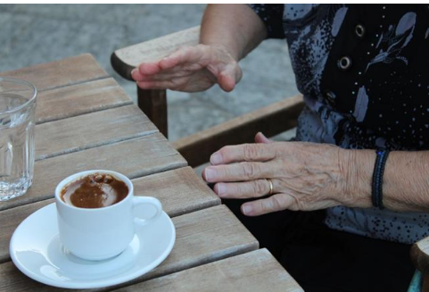
Photo by Anta Troullakis
Dr. Yiorgos Topalidis
Thursday 27/11/2025
When: Thursday Thursday 27/11/2025, 16:00-18:00
How: via zoom/ link to be sent to those who register
Language: English/Greek
All LNR seminars are free but require pre-registration.
To register please email Ms Vasileia Moschou vmoschoa@enl.auth.gr.
Participants will receive a certificate of attendance
This workshop provides an overview of oral history methodology using a practical approach. Originating in the field of anthropology, oral history has been utilized as a method by historians for decades. The workshop will focus on the process through which oral historians achieve the bottom-up perspective that is a feature of oral history methodology and how its use results in new interpretations of historical events. Although the workshop will be delivered online, it is hands-on. Students will receive an introduction to the hardware and software used by experts and scholars. Moreover, they will learn about the considerations, benefits, and challenges of the method and participate in an oral history exercise that tasks them with applying their newfound knowledge.

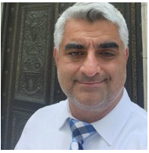
Bio
Dr. Yiorgos Topalidis is a Visiting Lecturer in the Department of Behavioral Sciences at Flagler College. Dr. Topalidis received a doctorate in Sociology from the University of Florida in 2022. Yiorgo’s research interests are emigration from the Ottoman Empire to the US and White identity construction, contestation, and transgenerational memory transfer. His most recent publications are in the Journal of Modern Greek Studies, the Journal of Sociology of Race and Ethnicity, and the Journal of Urban History. He is working on a monograph exploring the social construction of Ottoman Greek migrant identity in an early-20th-century US context as a case study for decoupling Whiteness from White supremacist Whiteness.

